=============子查询============

查询工资比WARD高的员工信息

SELECT * FROM EMP WHERE SAL >(SELECT SAL FROM EMP WHERE ENAME='WARD');



SELECT * FROM EMP WHERE DEPTNO=(SELECT DEPTNO FROM DEPT WHERE DNAME='SALES');

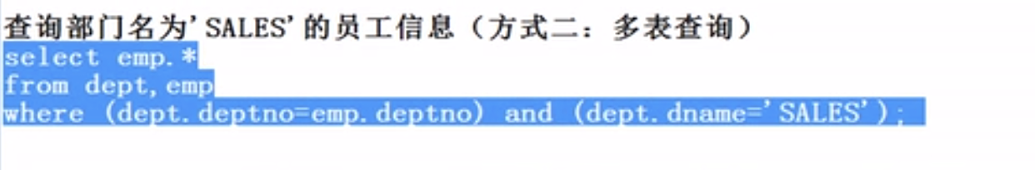

SELECT EMP.* FROM DEPT,EMP WHERE (DEPT.DEPTNO=EMP.DEPTNO) AND (DEPT.DNAME='SALES');

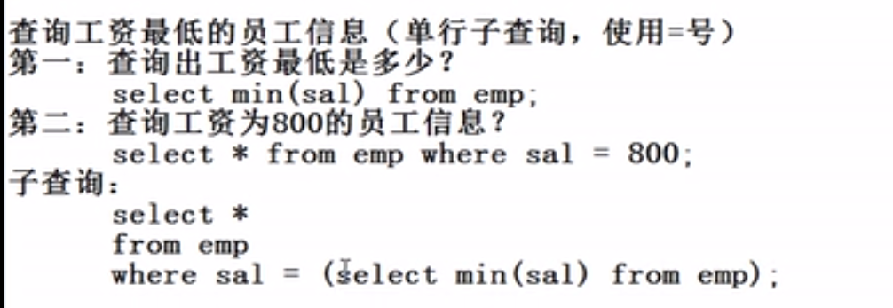

select * from emp where sal=(select min(sal) from emp);

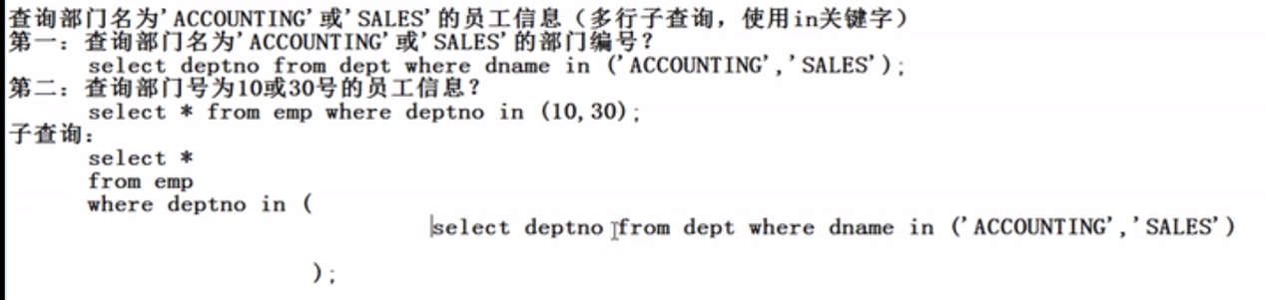

select * from emp where deptno in (select deptno from dept where dname in ('ACCOUNTING','SALES')); **注意：字符串里面的字符是大小写敏感的**



**select * from emp where sal< any (select sal from emp where deptno=20);**

**注意，在Oracle中<any 就是<最大那个**

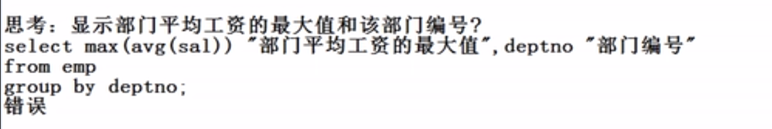

**select max(avg(sal)) "部门平均工资最大值" ,deptno "部门编号" from emp group by deptno; 错误**

**select deptno "部门编号"， max(avg(sal)) "部门平均工资最大值" from emp group by deptno; 也是错误；**

**select deptno "部门编号" from emp where avg(sal)=(select max(avg(sal)) from emp group by deptnp); 也是错误：ORA-00934: 此处不允许使用分组函数**

**结论：普通字段和多行函数不能同时出现在同一个查询语句中，**

**（ 思路：1.create table avgsal as select deptno,avg(sal) avgsal from emp group by deptno;**

**表已创建。**

**SQL> 2.select * from avgsal where avgsal=(select max(avgsal) from avgsal);）**

**需要多次使用子查询才能实现，以下是完整实现**

**select * from (select deptno, avg(sal) avgsal from emp group by deptno) xx where xx.avgsal=(select max(avgsal) from (select deptno,avg(sal) avgsal from emp group by deptno)); 正确**

**select * from (select deptno 部门编号, avg(sal) 平均工资 from emp group by deptno) xx where xx. 平均工资=(select max(平均工资) from (select deptno,avg(sal) 平均工资 from emp group by deptno));**

**select * from (select deptno 部门编号, avg(sal) 最高平均工资 from emp group by deptno) xx where xx. 最高平均工资=(select max(最高平均工资) from (select deptno,avg(sal) 最高平均工资 from emp group by deptno));**

**select xx.* from (select deptno 部门编号, avg(sal) 最高平均工资 from emp group by deptno) xx where xx. 最高平均工资=(select max(最高平均工资) from (select deptno,avg(sal) 最高平均工资 from emp group by deptno));**

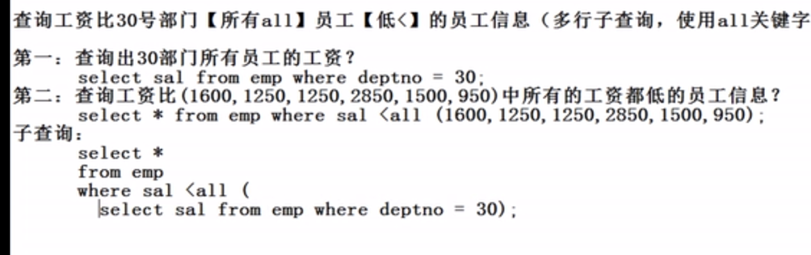

**select * from emp where sal< all (select sal from emp where deptno=30);**

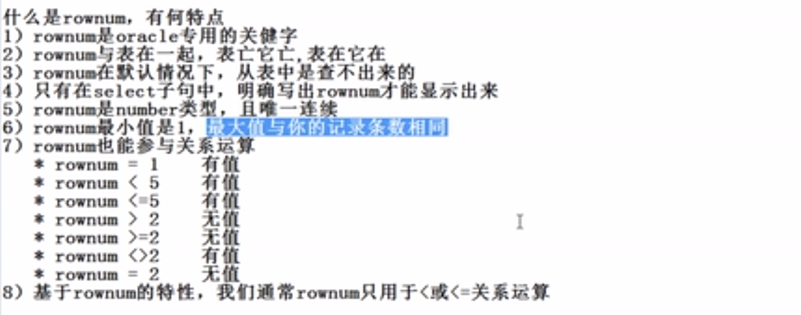

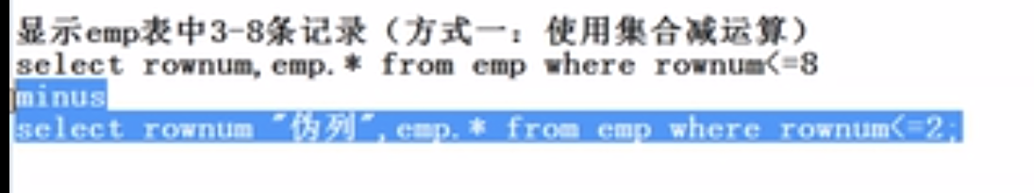

**select rownum,emp.* from emp where rownum<=8 minus select rownum "伪列",emp.* from emp where rownum<=2;**

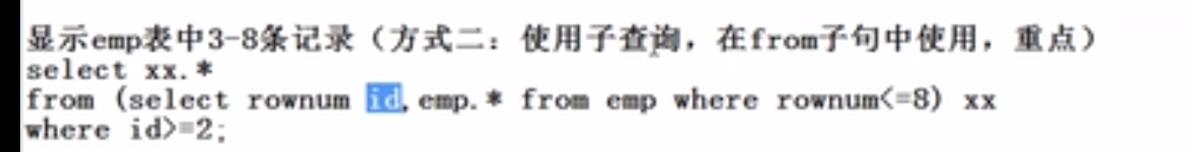

**Select xx.* from (select rownum id,emp.* from emp where rownum<=8) xx where id>2; 难点**



**select * from (select rownum ids ,emp.* from emp where rownum<=9) where ids>=5;**





